**MY CONTACTS APP**

**Name: Jaywant Lugun**

**Regno. 11904021**

**Roll no. RKO105A30**

**Working of Application**

**Splash screen with progress bar**

**Progress Bar**

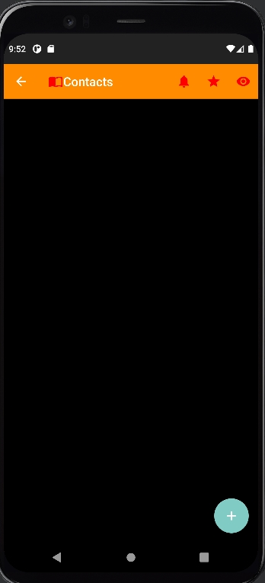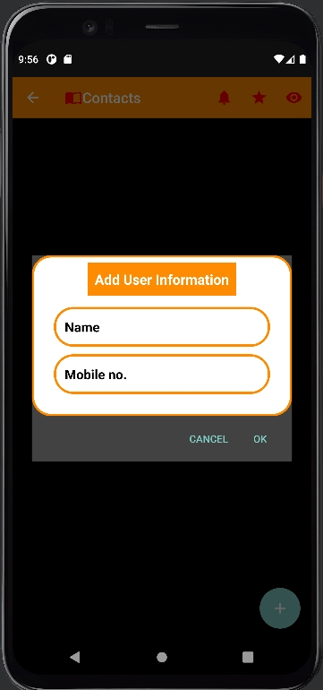 **Toolbar**

**when plus button is clicked**

**After adding multiple User information**

**Types of mode (on clicking Eye button on top right of Toolbar )**

**(Dark mode) (Light mode)**

**When 3 dots are clicked on the right side (Edit and delete option)**

**when Edit Text is clicked**

**Clicking on OK**

**On clicking delete button**

**Yes->**

**On clicking star, Rating dialog box**

**Will popup**

**On clicking notification**

**Message display below**

**CODING PART**

JAVA FOLDER

**contact_splash.kt**

package com.example.myapplication  
  
import android.content.Intent  
import androidx.appcompat.app.AppCompatActivity  
import android.os.Bundle  
import android.os.Handler  
  
class contact_splash : AppCompatActivity() {  
  
 lateinit var handler: Handler  
 override fun onCreate(savedInstanceState: Bundle?) {  
 super.onCreate(savedInstanceState)  
 setContentView(R.layout.*activity_contact_splash*)  
  
 handler = Handler()  
 handler.postDelayed(**{** val intent= Intent(this,contact2::class.*java*)  
 startActivity(intent)  
 finish()  
 **}**, 4000) //delay 4second  
  
  
 }  
}

**Contact2.kt (main activity)**

package com.example.myapplication  
  
import android.graphics.Color  
import android.os.Bundle  
import android.view.LayoutInflater  
import android.view.Menu  
import android.view.MenuItem  
import android.widget.*  
import androidx.appcompat.app.AlertDialog  
import androidx.appcompat.app.AppCompatActivity  
import androidx.recyclerview.widget.LinearLayoutManager  
import androidx.recyclerview.widget.RecyclerView  
import com.example.myapplication.model.UserData  
import com.example.myapplication.view.UserAdapter  
import com.google.android.material.floatingactionbutton.FloatingActionButton  
import kotlinx.android.synthetic.main.activity_contact2.*  
import kotlinx.android.synthetic.main.add_item.*  
  
  
class contact2 : AppCompatActivity() {  
 var flag=1  
 private lateinit var addsBtn:FloatingActionButton  
 private lateinit var recv:RecyclerView  
 private lateinit var userList: ArrayList<UserData>  
 private lateinit var userAdapter: UserAdapter  
 override fun onCreate(savedInstanceState: Bundle?) {  
 super.onCreate(savedInstanceState)  
 setContentView(R.layout.*activity_contact2*)  
  
  
 //set List  
 userList= ArrayList()  
 //set find id  
 addsBtn=findViewById(R.id.*addingBtn*)  
 recv=findViewById(R.id.*mRecycler*)  
 //set Adapter  
 userAdapter= UserAdapter(this,userList)  
 //Set RecycleView adapter  
 recv.*layoutManager*=LinearLayoutManager(this)  
 recv.*adapter*=userAdapter  
 //set Dialog  
 addsBtn.setOnClickListener**{** addInfo()**}** setSupportActionBar(toolbar)  
 toolbar.setNavigationOnClickListener**{** Toast.makeText(this,"Navigation Menu Clicked",Toast.*LENGTH_SHORT*).show()  
 **}** }  
  
  
  
  
 private fun addInfo() {  
 val inflter=LayoutInflater.from(this)  
 val v=inflter.inflate(R.layout.*add_item*,null)  
  
 //Set View  
 val userName=v.findViewById<EditText>(R.id.*userName*)  
 val userNo=v.findViewById<EditText>(R.id.*userNo*)  
  
 val addDialog=AlertDialog.Builder(this)  
 addDialog.setView(v)  
 addDialog.setPositiveButton("Ok")**{** dialog,_**->** val names=userName.*text*.toString()  
 val number=userNo.*text*.toString()  
 userList.add(UserData("Name: $names","Mobile No. : $number"))  
 userAdapter.notifyDataSetChanged()  
 Toast.makeText(this,"Updated Successfully",Toast.*LENGTH_SHORT*).show()  
 dialog.dismiss()  
 **}** addDialog.setNegativeButton("Cancel")**{** dialog,_**->** dialog.dismiss()  
 Toast.makeText(this,"Cancel",Toast.*LENGTH_SHORT*).show()  
 **}** addDialog.create()  
 addDialog.show()  
  
  
  
  
  
  
 }  
// top 3 dots  
 override fun onCreateOptionsMenu(menu: Menu): Boolean {  
 *menuInflater*.inflate(R.menu.*option_mode*,menu)  
 return true  
 }  
  
 override fun onOptionsItemSelected(item: MenuItem): Boolean {  
 val id=item.*itemId* return when (id) {  
 R.id.*Dark_mode* -> {  
  
 if(flag==0){  
 contact_bg.setBackgroundColor(Color.*BLACK*)  
 flag=1  
 }  
 else if(flag==1){  
 contact_bg.setBackgroundColor(Color.*WHITE*)  
 flag=0  
 }  
 true  
 }  
 R.id.*Crate* -> {  
  
 val inflter=LayoutInflater.from(this)  
 val v=inflter.inflate(R.layout.*contact_user_rating*,null)  
  
 //Set View  
 val ratingBar=findViewById<RatingBar>(R.id.*ratingBar*)  
  
 val addDialog=AlertDialog.Builder(this)  
 addDialog.setView(v)  
 addDialog.setPositiveButton("Ok")**{** dialog,_**->** val rating: String = java.lang.String.valueOf(ratingBar.*rating*)  
 dialog.dismiss()  
 Toast.makeText(this, rating, Toast.*LENGTH_LONG*).show()  
  
 **}** addDialog.setNegativeButton("Cancel")**{** dialog,_**->** dialog.dismiss()  
 Toast.makeText(this,"Cancel",Toast.*LENGTH_SHORT*).show()  
 **}** addDialog.create()  
 addDialog.show()  
  
 true  
 }  
 R.id.*notify* -> {  
 Toast.makeText(this,"Notification is clicked",Toast.*LENGTH_SHORT*).show()  
 true  
 }  
  
 else -> super.onOptionsItemSelected(item)  
 }  
  
  
 }  
  
  
}

JAVA FOLDER -> MODEL

UserData.kt

package com.example.myapplication.model  
  
data class UserData (  
 var userName:String,  
 var userMb:String  
)

JAVA FOLDER -> VIEW

UserAdapter.kt

package com.example.myapplication.view  
  
import android.app.AlertDialog  
import android.content.Context  
import android.view.LayoutInflater  
import android.view.View  
import android.view.ViewGroup  
import android.widget.*  
import androidx.recyclerview.widget.RecyclerView  
import com.example.myapplication.R  
import com.example.myapplication.model.UserData  
import org.w3c.dom.Text  
  
class UserAdapter(val c:Context,val userList:ArrayList<UserData>):RecyclerView.Adapter<UserAdapter.UserViewHolder>()  
{  
  
 inner class UserViewHolder(val v:View):RecyclerView.ViewHolder(v){  
 var name:TextView  
 var mbNum:TextView  
 var mMenus:ImageView  
  
 init {  
 name=v.findViewById<TextView>(R.id.*mTitle*)  
 mbNum=v.findViewById<TextView>(R.id.*mSubTitle*)  
 mMenus=v.findViewById(R.id.*mMenus*)  
 mMenus.setOnClickListener**{** popupMenus(**it**)**}** }  
  
 private fun popupMenus(v:View) {  
 val position=userList[*adapterPosition*]  
 val popupMenus=PopupMenu(c,v)  
 popupMenus.inflate(R.menu.*show_menu*)  
 popupMenus.setOnMenuItemClickListener **{** when(**it**.*itemId*){  
 R.id.*editText*->{  
 val v=LayoutInflater.from(c).inflate(R.layout.*add_item*,null)  
 val name=v.findViewById<EditText>(R.id.*userName*)  
 val number=v.findViewById<EditText>(R.id.*userNo*)  
  
 //work in progress  
  
 //number.setText(mbNum.text.toString())  
 AlertDialog.Builder(c)  
 .setView(v)  
 .setPositiveButton("Ok")**{** dialog,_**->** val nam=("Name: "+name.*text*.toString())  
 position.userName=nam  
 val mob=("Mobile No. : "+number.*text*.toString())  
 position.userMb=mob  
 notifyDataSetChanged()  
 Toast.makeText(c,"User Data Updated",Toast.*LENGTH_SHORT*).show()  
 dialog.dismiss()  
 **}** .setNegativeButton("Cancel")**{** dialog,_**->** dialog.dismiss()  
  
 **}** .create()  
 .show()  
  
  
 true  
 }  
 R.id.*delete*->{  
 //set delete  
 AlertDialog.Builder(c)  
 .setTitle("Delete")  
 .setIcon(R.drawable.*ic_warning*)  
 .setMessage("Are yo sure to delete this Information")  
 .setPositiveButton("Yes")**{** dialog,_**->** userList.removeAt(*adapterPosition*)  
 notifyDataSetChanged()  
 Toast.makeText(c,"Deleted Successfully",Toast.*LENGTH_SHORT*).show()  
 dialog.dismiss()  
 **}** .setNegativeButton("No")**{** dialog,_**->** dialog.dismiss()  
 **}** .create()  
 .show()  
 true  
 }  
 else-> true  
 }  
 **}** popupMenus.show()  
 val popup=PopupMenu::class.*java*.getDeclaredField("mPopup")  
 popup.*isAccessible*=true  
 val menu=popup.get(popupMenus)  
 menu.*javaClass*.getDeclaredMethod("setForceShowIcon",Boolean::class.*java*).invoke(menu,true)  
 }  
  
 }  
  
 override fun onCreateViewHolder(parent: ViewGroup, viewType: Int): UserViewHolder {  
 val inflater=LayoutInflater.from(parent.*context*)  
 val v=inflater.inflate(R.layout.*list_item*,parent,false)  
 return UserViewHolder(v)  
 }  
  
 override fun onBindViewHolder(holder: UserViewHolder, position: Int) {  
 val newList=userList[position]  
 holder.name.*text*=newList.userName  
 holder.mbNum.*text*=newList.userMb  
 }  
  
 override fun getItemCount(): Int {  
 return userList.size  
 }  
  
  
}

RESOURCE FOLDER (res)

* Drawable

Ic_add.xml

<vector xmlns:android="http://schemas.android.com/apk/res/android"  
 android:width="24dp"  
 android:height="24dp"  
 android:viewportWidth="24"  
 android:viewportHeight="24"  
 android:tint="?attr/colorControlNormal">  
 <path  
 android:fillColor="@android:color/white"  
 android:pathData="M19,13h-6v6h-2v-6H5v-2h6V5h2v6h6v2z"/>  
</vector>

Ic_delete.xml

<vector android:height="24dp" android:tint="#FF0000"  
 android:viewportHeight="24" android:viewportWidth="24"  
 android:width="24dp" xmlns:android="http://schemas.android.com/apk/res/android">  
 <path android:fillColor="@android:color/white" android:pathData="M6,19c0,1.1 0.9,2 2,2h8c1.1,0 2,-0.9 2,-2V7H6v12zM19,4h-3.5l-1,-1h-5l-1,1H5v2h14V4z"/>  
</vector>

Ic_edit.xml

<vector android:height="24dp" android:tint="#364ACC"  
 android:viewportHeight="24" android:viewportWidth="24"  
 android:width="24dp" xmlns:android="http://schemas.android.com/apk/res/android">  
 <path android:fillColor="@android:color/white" android:pathData="M3,17.25V21h3.75L17.81,9.94l-3.75,-3.75L3,17.25zM20.71,7.04c0.39,-0.39 0.39,-1.02 0,-1.41l-2.34,-2.34c-0.39,-0.39 -1.02,-0.39 -1.41,0l-1.83,1.83 3.75,3.75 1.83,-1.83z"/>  
</vector>

Ic_more.xml

<vector xmlns:android="http://schemas.android.com/apk/res/android"  
 android:width="24dp"  
 android:height="24dp"  
 android:viewportWidth="24"  
 android:viewportHeight="24"  
 android:tint="?attr/colorControlNormal">  
 <path  
 android:fillColor="@android:color/white"  
 android:pathData="M6,10c-1.1,0 -2,0.9 -2,2s0.9,2 2,2 2,-0.9 2,-2 -0.9,-2 -2,-2zM18,10c-1.1,0 -2,0.9 -2,2s0.9,2 2,2 2,-0.9 2,-2 -0.9,-2 -2,-2zM12,10c-1.1,0 -2,0.9 -2,2s0.9,2 2,2 2,-0.9 2,-2 -0.9,-2 -2,-2z"/>  
</vector>

Ic_warning.xml

<vector android:height="24dp" android:tint="#FF0000"  
 android:viewportHeight="24" android:viewportWidth="24"  
 android:width="24dp" xmlns:android="http://schemas.android.com/apk/res/android">  
 <path android:fillColor="@android:color/white" android:pathData="M1,21h22L12,2 1,21zM13,18h-2v-2h2v2zM13,14h-2v-4h2v4z"/>  
</vector>

Shape_background.xml

<?xml version="1.0" encoding="utf-8"?>  
<shape xmlns:android="http://schemas.android.com/apk/res/android">  
  
 <solid android:color="@color/white"/>  
 <stroke android:color="@color/orange" android:width="3dp"/>  
 <corners android:radius="25dp"/>  
  
</shape>

INSIDE LAYOUT

**Activity_contact_splash.xml**

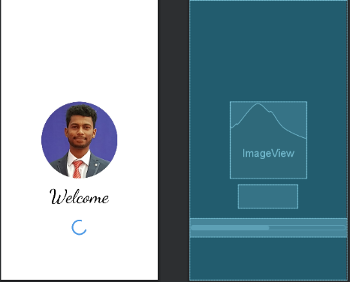

<?xml version="1.0" encoding="utf-8"?>  
<androidx.constraintlayout.widget.ConstraintLayout xmlns:android="http://schemas.android.com/apk/res/android"  
 xmlns:app="http://schemas.android.com/apk/res-auto"  
 xmlns:tools="http://schemas.android.com/tools"  
 android:layout_width="match_parent"  
 android:layout_height="match_parent"  
 tools:context=".contact_splash"  
 android:background="@color/white">  
  
 <ImageView  
 android:id="@+id/imageView"  
 android:layout_width="200dp"  
 android:layout_height="200dp"  
 android:src="@drawable/jaywantround"  
 app:layout_constraintBottom_toBottomOf="parent"  
 app:layout_constraintEnd_toEndOf="parent"  
 app:layout_constraintStart_toStartOf="parent"  
 app:layout_constraintTop_toTopOf="parent" />  
  
 <TextView  
 android:id="@+id/textView"  
 android:layout_width="wrap_content"  
 android:layout_height="wrap_content"  
 android:fontFamily="cursive"  
 android:text="Welcome"  
 android:textColor="@color/black"  
 android:textSize="50sp"  
 app:layout_constraintBottom_toBottomOf="parent"  
 app:layout_constraintEnd_toEndOf="parent"  
 app:layout_constraintHorizontal_bias="0.498"  
 app:layout_constraintStart_toStartOf="parent"  
 app:layout_constraintTop_toBottomOf="@+id/imageView"  
 app:layout_constraintVertical_bias="0.082" />  
  
 <ProgressBar  
 android:id="@+id/progress_bar"  
 android:layout_width="match_parent"  
 android:layout_height="wrap_content"  
 app:layout_constraintBottom_toBottomOf="parent"  
 app:layout_constraintTop_toBottomOf="@+id/textView"  
 app:layout_constraintVertical_bias="0.192"  
 tools:layout_editor_absoluteX="0dp"  
 android:indeterminateTint="@color/blue"/>  
  
  
</androidx.constraintlayout.widget.ConstraintLayout>

**Contact2.xml**

<?xml version="1.0" encoding="utf-8"?>  
<RelativeLayout xmlns:android="http://schemas.android.com/apk/res/android"  
 xmlns:app="http://schemas.android.com/apk/res-auto"  
 xmlns:tools="http://schemas.android.com/tools"  
 android:layout_width="match_parent"  
 android:layout_height="match_parent"  
 tools:context=".contact2"  
 android:orientation="vertical"  
 android:id="@+id/contact_bg"  
 android:background="@color/black">  
  
 <androidx.appcompat.widget.Toolbar  
 android:id="@+id/toolbar"  
 android:layout_width="match_parent"  
 android:layout_height="wrap_content"  
 android:background="@color/orange"  
 android:theme="@style/ThemeOverlay.AppCompat.Dark.ActionBar"  
 app:logo="@drawable/ic_baseline_import_contacts_24"  
 app:navigationIcon="?attr/homeAsUpIndicator"  
 app:title="Contacts"  
 app:titleMarginStart="10dp" />  
  
  
  
 <ScrollView  
 android:layout_width="match_parent"  
 android:layout_height="wrap_content"  
 android:fillViewport="false"  
 android:layout_below="@+id/toolbar">  
  
  
 <LinearLayout  
 android:layout_width="match_parent"  
 android:layout_height="wrap_content"  
 android:orientation="vertical">  
  
  
  
 <androidx.recyclerview.widget.RecyclerView  
 android:id="@+id/mRecycler"  
 android:layout_width="match_parent"  
 android:layout_height="match_parent"/>  
  
  
 </LinearLayout>  
 </ScrollView>  
  
 <com.google.android.material.floatingactionbutton.FloatingActionButton  
 android:id="@+id/addingBtn"  
 app:tint="@color/white"  
 android:src="@drawable/ic_add"  
 android:layout_width="wrap_content"  
 android:layout_height="wrap_content"  
 android:layout_alignParentBottom="true"  
 android:layout_alignParentEnd="true"  
 android:layout_margin="15dp"  
 />  
  
  
</RelativeLayout>

Add_item.xml

<?xml version="1.0" encoding="utf-8"?>  
<LinearLayout xmlns:android="http://schemas.android.com/apk/res/android"  
 android:layout_width="match_parent"  
 android:layout_height="match_parent"  
 android:gravity="center"  
 android:layout_margin="15dp">  
  
 <LinearLayout  
 android:paddingBottom="15dp"  
 android:paddingRight="15dp"  
 android:paddingLeft="15dp"  
 android:paddingTop="10dp"  
 android:orientation="vertical"  
 android:background="@drawable/shape_background"  
 android:layout_width="match_parent"  
 android:layout_height="wrap_content">  
  
 <TextView  
 android:layout_width="wrap_content"  
 android:layout_height="wrap_content"  
 android:text="Add User Information"  
 android:textStyle="bold"  
 android:paddingLeft="15dp"  
 android:paddingRight="15dp"  
 android:paddingBottom="8dp"  
 android:paddingTop="8dp"  
 android:background="@color/orange"  
 android:textSize="19sp"  
 android:padding="10dp"  
 android:gravity="center"  
 android:layout_gravity="center"  
 android:textColor="@color/white"/>  
  
 <EditText  
 android:id="@+id/userName"  
 android:padding="15dp"  
 android:background="@drawable/shape_background"  
 android:inputType="textPersonName"  
 android:layout_width="match_parent"  
 android:layout_height="wrap_content"  
 android:hint="Name"  
 android:textColorHint="@color/black"  
 android:layout_marginLeft="15dp"  
 android:layout_marginRight="15dp"  
 android:layout_marginBottom="5dp"  
 android:layout_marginTop="15dp"  
 android:textColor="@color/orange"  
 android:textSize="18sp"  
 android:textStyle="bold" />  
  
 <EditText  
 android:id="@+id/userNo"  
 android:padding="15dp"  
 android:background="@drawable/shape_background"  
 android:layout_width="match_parent"  
 android:layout_height="wrap_content"  
 android:hint="Mobile no."  
 android:inputType="phone"  
 android:layout_marginLeft="15dp"  
 android:layout_marginRight="15dp"  
 android:layout_marginBottom="15dp"  
 android:layout_marginTop="5dp"  
 android:textColorHint="@color/black"  
 android:textColor="@color/orange"  
 android:textSize="18sp"  
 android:textStyle="bold"/>  
  
  
  
  
 </LinearLayout>  
  
</LinearLayout>

List_item.xml

<?xml version="1.0" encoding="utf-8"?>  
<androidx.cardview.widget.CardView xmlns:android="http://schemas.android.com/apk/res/android"  
 android:layout_width="match_parent"  
 android:layout_height="wrap_content"  
 xmlns:app="http://schemas.android.com/apk/res-auto"  
 app:cardCornerRadius="10dp"  
 app:cardElevation="8dp"  
 app:cardMaxElevation="5dp"  
 android:layout_margin="10dp"  
 android:id="@+id/list_item_card_bg">  
  
 <LinearLayout  
 android:id="@+id/list_item_bg"  
 android:layout_width="match_parent"  
 android:layout_height="wrap_content"  
 android:orientation="horizontal">  
  
 <LinearLayout  
 android:layout_weight="1"  
 android:layout_margin="15dp"  
 android:padding="4dp"  
 android:orientation="vertical"  
 android:layout_width="wrap_content"  
 android:layout_height="wrap_content">  
  
 <TextView  
 android:id="@+id/mTitle"  
 android:text="Title"  
 android:textColor="@color/black"  
 android:textSize="19sp"  
 android:textStyle="bold"  
 android:layout_margin="6dp"  
 android:layout_width="match_parent"  
 android:layout_height="wrap_content"/>  
  
 <TextView  
 android:id="@+id/mSubTitle"  
 android:text="SubTitle"  
 android:textColor="@android:color/darker_gray"  
 android:textSize="15sp"  
 android:textStyle="bold"  
 android:layout_margin="6dp"  
 android:layout_width="match_parent"  
 android:layout_height="wrap_content"/>  
  
  
  
 </LinearLayout>  
  
 <ImageView  
 android:id="@+id/mMenus"  
 android:layout_width="40dp"  
 android:layout_height="40dp"  
 android:src="@drawable/ic_more"  
 android:layout_margin="10dp"  
 android:layout_gravity="center"/>  
  
 </LinearLayout>  
</androidx.cardview.widget.CardView>

**Contact_user_rating.xml**

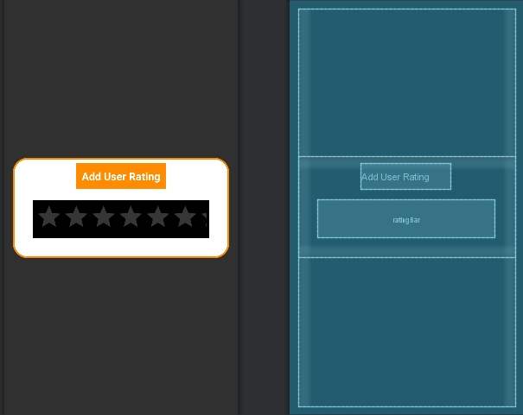

<?xml version="1.0" encoding="utf-8"?>  
<LinearLayout xmlns:android="http://schemas.android.com/apk/res/android"  
 android:layout_width="match_parent"  
 android:layout_height="match_parent"  
 android:gravity="center"  
 android:layout_margin="15dp">  
  
 <LinearLayout  
 android:paddingBottom="15dp"  
 android:paddingRight="15dp"  
 android:paddingLeft="15dp"  
 android:paddingTop="10dp"  
 android:orientation="vertical"  
 android:background="@drawable/shape_background"  
 android:layout_width="match_parent"  
 android:layout_height="wrap_content">  
  
 <TextView  
 android:layout_width="wrap_content"  
 android:layout_height="wrap_content"  
 android:text="Add User Rating"  
 android:textStyle="bold"  
 android:paddingLeft="15dp"  
 android:paddingRight="15dp"  
 android:paddingBottom="8dp"  
 android:paddingTop="8dp"  
 android:background="@color/orange"  
 android:textSize="19sp"  
 android:padding="10dp"  
 android:gravity="center"  
 android:layout_gravity="center"  
 android:textColor="@color/white"/>  
  
 <RatingBar  
 android:id="@+id/ratingBar"  
 android:layout_width="match_parent"  
 android:layout_height="wrap_content"  
 android:layout_gravity="center"  
 android:padding="5dp"  
 android:layout_margin="20dp"  
 android:background="@color/black"  
 />  
  
  
 </LinearLayout>  
  
</LinearLayout>

INSIDE MENU

Option_mode.xml

<?xml version="1.0" encoding="utf-8"?>  
<menu xmlns:android="http://schemas.android.com/apk/res/android"  
 xmlns:app="http://schemas.android.com/apk/res-auto">  
  
 <item  
 android:id="@+id/notify"  
 android:title="notification"  
 android:icon="@drawable/ic_baseline_notifications_24"  
 android:iconTint="@color/black"  
 app:showAsAction="always"  
 />  
  
 <item android:title="R"  
 android:id="@+id/Crate"  
 android:iconTint="@color/black"  
 android:icon="@drawable/ic_baseline_star_24"  
 android:orderInCategory="100"  
 app:showAsAction="always"/>  
  
  
  
 <item android:title="Eye"  
 android:id="@+id/Dark_mode"  
 android:icon="@drawable/ic_baseline_visibility_24"  
 android:iconTint="@color/black"  
 android:orderInCategory="200"  
 app:showAsAction="always"/>  
  
  
</menu>

Show_menu.xml

<?xml version="1.0" encoding="utf-8"?>  
<menu xmlns:android="http://schemas.android.com/apk/res/android">  
  
 <!--adding icons-->  
 <item  
 android:id="@+id/editText"  
 android:title="Edit Text"  
 android:icon="@drawable/ic_edit"  
 />  
 <item  
 android:id="@+id/delete"  
 android:title="Delete"  
 android:icon="@drawable/ic_delete"  
 />  
  
</menu>

INSIDE VALUES

Strings.xml

<resources>  
 <string name="app_name">My Application</string>  
 <string name="my_contact">My Contacts</string>  
</resources>

Styles.xml

<?xml version="1.0" encoding="utf-8"?>  
<resources>  
   
 <style name="CustomDialog">  
 <item name="android:windowIsTranslucent">true</item>  
 <item name="android:windowBackground">@android:color/transparent</item>  
 </style>  
   
</resources>

Themes.xml

<resources xmlns:tools="http://schemas.android.com/tools">  
 <!-- Base application theme. -->  
 <style name="Theme.MyApplication" parent="Theme.AppCompat.NoActionBar">  
 <!-- Primary brand color. -->  
 <item name="colorPrimary">@color/orange</item>  
 <item name="colorPrimaryVariant">@color/almostBlack</item>  
 <item name="colorOnPrimary">@color/white</item>  
  
 <!-- Status bar color. -->  
 <item name="android:statusBarColor" tools:targetApi="l">?attr/colorPrimaryVariant</item>  
 <!-- Customize your theme here. -->  
 </style>  
</resources>

AndroidManifest.xml

<?xml version="1.0" encoding="utf-8"?>  
<manifest xmlns:android="http://schemas.android.com/apk/res/android"  
 package="com.example.myapplication">  
  
 <uses-permission android:name="android.permission.CAMERA" />  
 <uses-permission android:name="android.permission.READ_EXTERNAL_STORAGE" />  
  
 <application  
 android:allowBackup="true"  
 android:icon="@mipmap/ic_launcher"  
 android:label="@string/my_contact"  
 android:roundIcon="@mipmap/ic_launcher_round"  
 android:supportsRtl="true"  
 android:theme="@style/Theme.MyApplication">  
 <activity  
 android:name=".contact_splash"  
 android:exported="true">  
 <intent-filter>  
 <action android:name="android.intent.action.MAIN" />  
  
 <category android:name="android.intent.category.LAUNCHER" />  
 </intent-filter>  
 </activity>

</application>  
  
</manifest>